Incomplete Performance form
Move any incomplete forms to completed status

Proxy as Micheal Keinath

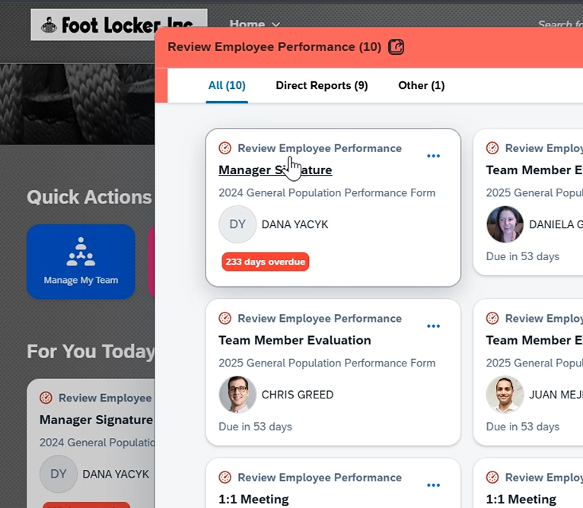

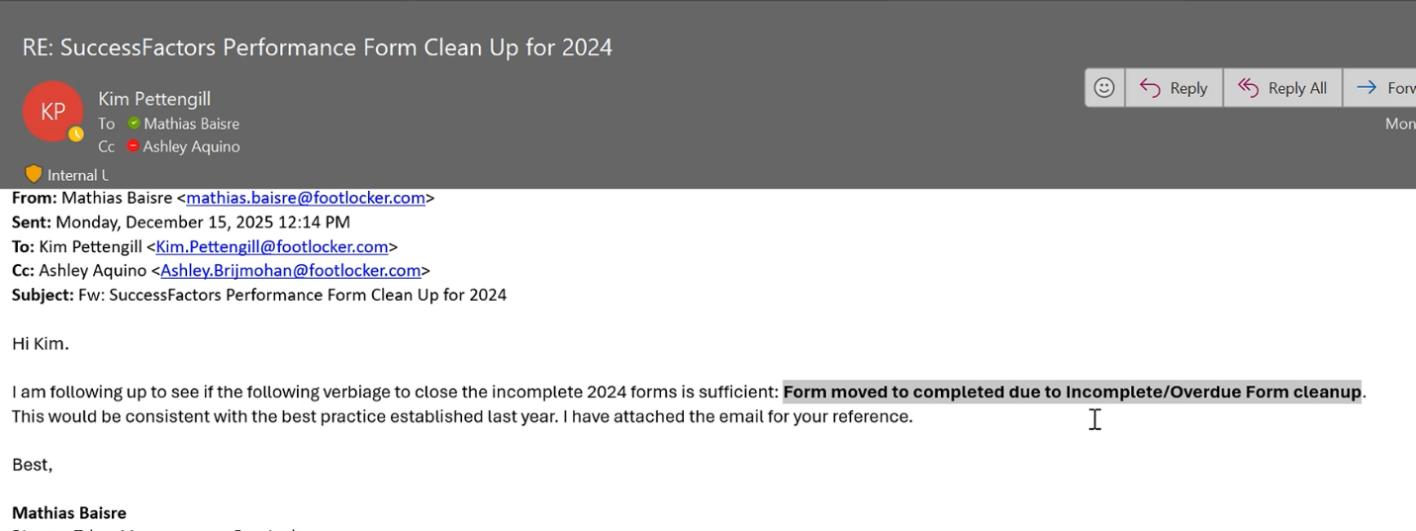

Update the report with this year's Performance form template
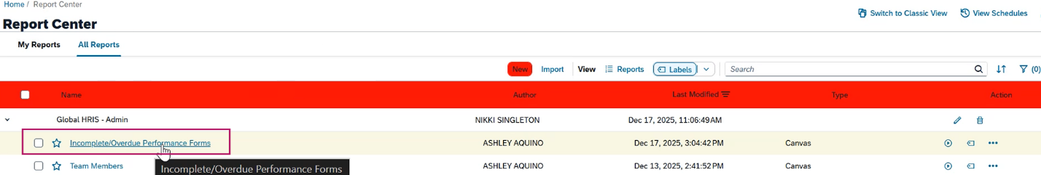

Run the report and save the report
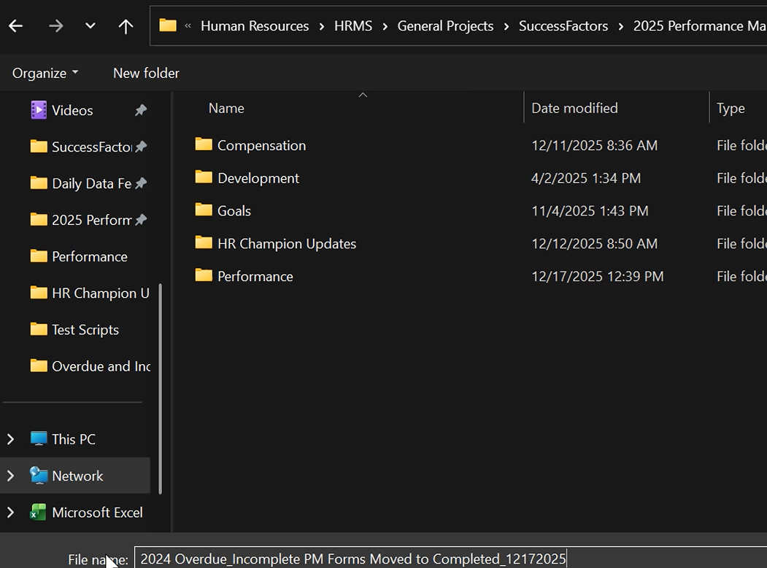

Proxy in as Global Admin
Route Form >download template for form Ids> copy paste Form Ids

Save in the folder
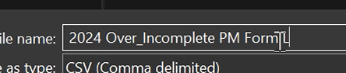

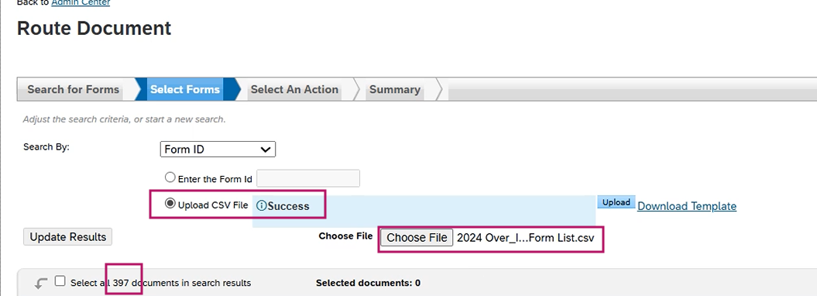

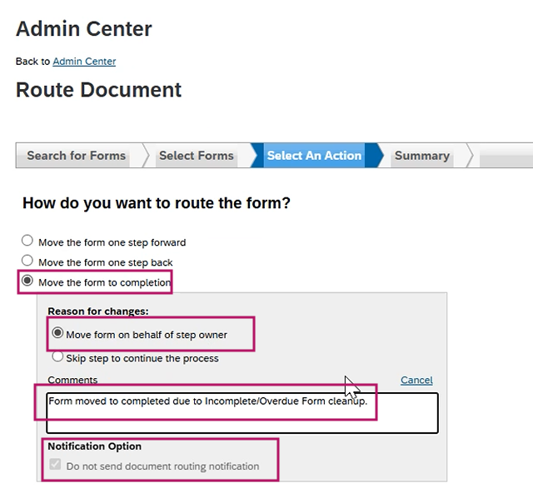

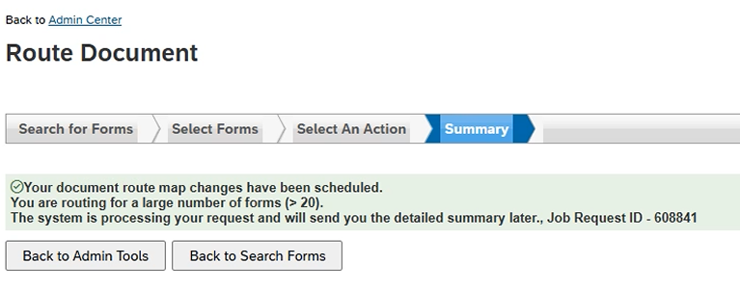

Scheduled Job Manager - To check the completion of the job

View a few validations after the forms move over

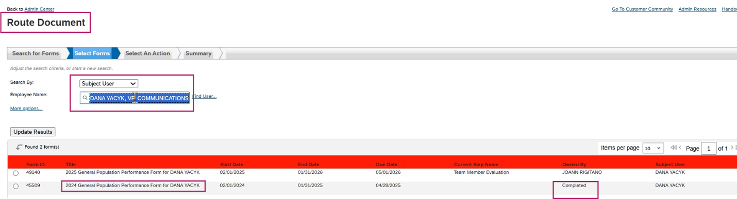

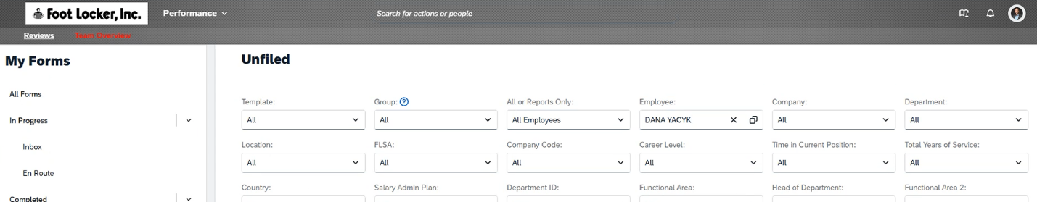

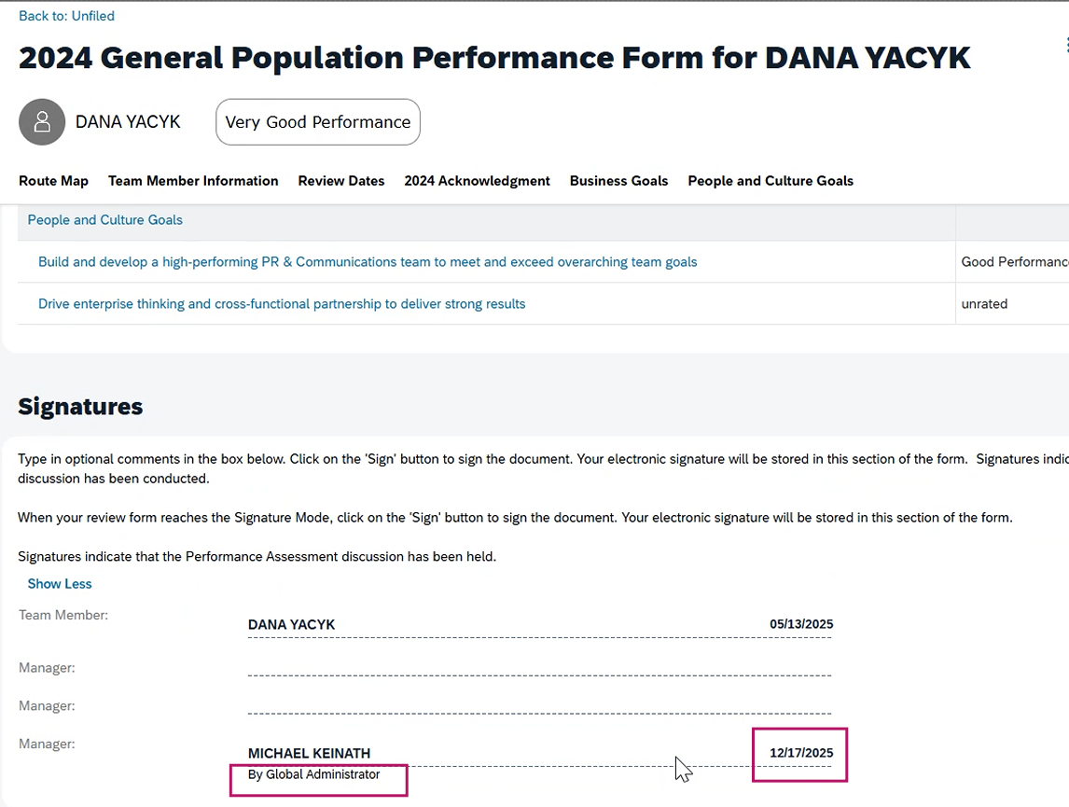

Run the same Overdue Incomplete report
The expectation is there will be nobody in that report now that the forms are mass paused to completion

One person was not pushed to completion
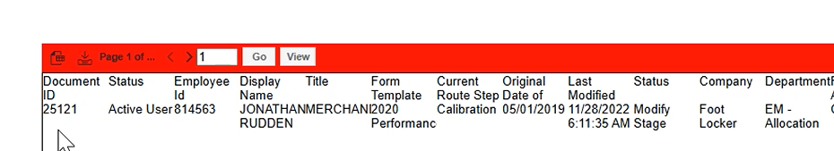

Proxy as Global Admin > Route Form > Form

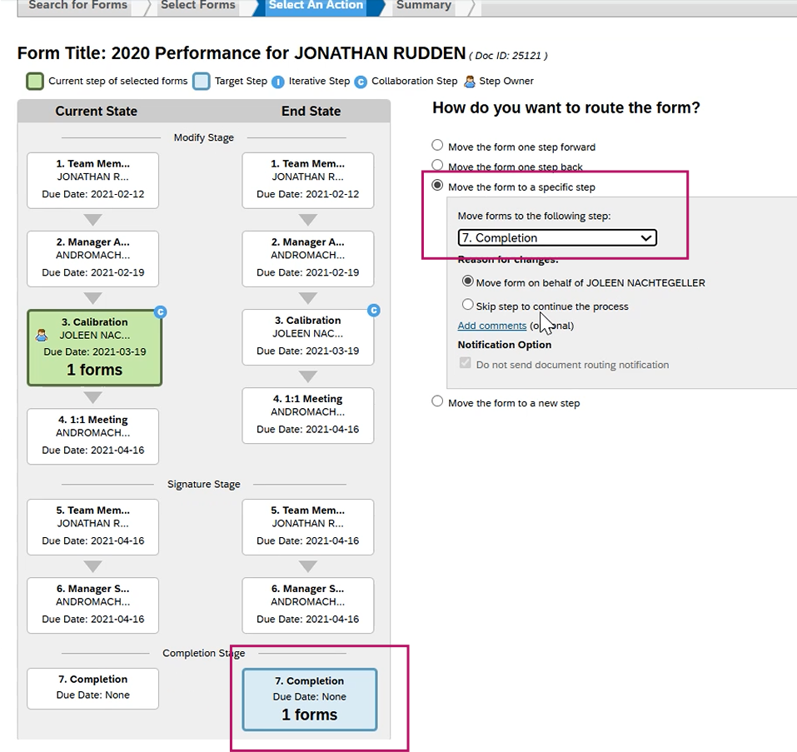

Modify Form Route map
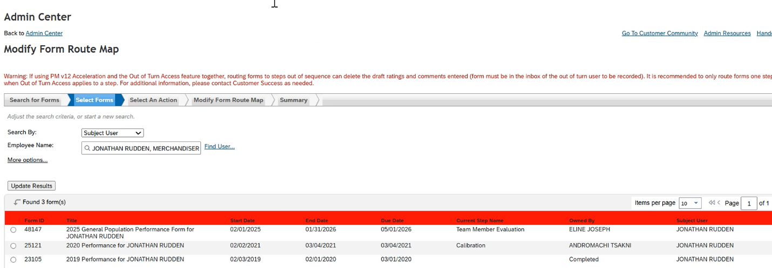

Let TM know the list of incompleted forms are pushed to completed and let them know so that they can Archive the \List as well.

